**REAL ESTATE VALUATION USING**

**MACHINE LEARNING**

*Dissertation submitted*

*in partial fulfilment of requirements for the award of the degree of*

**Master of Computer Applications (M.C.A)**

*Submitted By*

**SURI SAI PRAVEEN**

(Regd. No: 21131F0065)

*Under the esteemed guidance of*

**Mr. B. BALAKRISHNA**

**Assistant Professor**

**Department of computer Applications**



**Department of Computer Applications**

**GAYATRI VIDYA PARISHAD COLLEGE OF ENGINEERING**

**(AUTONOMOUS)**

(Affiliated to JNTU-K, Kakinada)

**VISAKHAPATNAM-530048**

2021-2023

**CERTIFICATE**



**GAYATRI VIDYA PARISHAD COLLEGE OF ENGINEERING (AUTONOMOUS)**

This is to certify that, the dissertation **titled “REALESTATE VALUATION USING MACHINE LEARNING”** is submitted by **Mr. SURI SAI PRAVEEN** in partialfulfillment of the requirement forward of the Degree of **M.C.A** in **GAYATRI VIDYA PARISHAD COLLEGE OF ENGINEERING (AUTONOMOUS)** affiliated to Jawaharlal Nehru Technological University, Kakinada is **a** bonafide record of project carried out by him under my supervision.

The contents of the project report, in full or in parts, have not been submitted to any other Institute or University for the award of any degree.

**Internal Guide Head of the Department**

**External Examiner**

i

**DECLARATION**

I hereby declare the dissertation titled **“REAL ESTATE VALUATION USING MACHINE LEARNING”** is submitted to the Department of Computer Applications, **Gayatri Vidya Parishad College of Engineering(Autonomous)** affiliated to Jawaharlal Nehru Technological University, Kakinada in partial fulfilment of the requirements for the award of the degree of **Master of Computer Applications(MCA).** This work is done by me and authentic to the best of my knowledge under the direction and valuable guidance of **Mr. B. Balakrishna,** Assistant Professor in the Department of Computer Applications.

**(SURI SAI PRAVEEN)**

ii

**ACKNOWLEDGEMENT**

I take the opportunity to thank everyone who has contributed to making the project possible. I am thankful to Gayatri Vidya parishad College of Engineering (Autonomous) for giving opportunity me to work on a project as part of the curriculum.

I offer my copious thanks to **Dr. A. B. Koteswara Rao**, the principal of **Gayatri Vidya Parishad College of Engineering (Autonomous)** for providing the best faculty and lab facilities throughout the completion of Master of Computer Applications course.

I offer my copious thanks to Prof. **Dr. K. Narasimha Rao,** M.Tech., Ph.D., Professor and Dean, Academics (PG) for his valuable suggestions and constant motivation that greatly helped me complete project successfully.

I offer my profuse thanks to **Dr. Y. Anuradha**, Associate Professor, Head of the Department of Computer Applications for her valuable suggestions and constant motivation that greatly helped me to complete the project successfully.

My sincere thanks to **Mr. B. Balakrishna**, Assistant Professor, Department of Computer Applications, my project guide, for his constant support, encouragement. I am very much grateful for his valuable suggestions.

**SURI SAI PRAVEEN**

**(21131F0065)**

iii

**ABSTRACT**

Buying a dream house is a common aspiration for people in these days, but accurately predicting its price has become more challenging, especially for those without expertise in this field. This difficulty often hinders informed decision-making when it comes to purchasing property. However, there is a proposed system that aims to simplify house price prediction by considering crucial factors. The system utilizes multiple regression techniques and calculates their results through weighted averaging, leading to highly accurate predictions. This approach minimizes error and enhances accuracy .

iv

**INDEX**

*Certificate i*

*Declaration ii*

*Acknowledgement iii*

*Abstract iv*

*Table of contents v, vi*

*List of Figures vii*

*List of Tables vii*

**TABLE OF CONTENTS**

**CHAPTER NAME PAGE NO**

1. **INTRODUCTION……………………………………………………………...1**

1.1 INTRODUCTION……………………………………………...…………...2

1. **LITERATURE REVIEW………………………………………...…...............3**

2.1 LITERATURE REVIEW……………………………………...…………....4

1. **SYSTEM ANALYSIS……………………………………………..………..…5**
   1. EXISTING SYSTEM…………..………………………………................6
   2. PROPOSED SYSTEM…………………………………………..……..…6
2. **SYSTEM REQUIREMENTS AND SPECIFICATION…………….…..….7**
   1. HARDWARE REQUIREMENTS…………………………………..........8
   2. SOFTWARE REQUIREMENTS…………………………………….......8
   3. FUNCTIONAL REQUIREMENTS…………………………………...…9
   4. NON-FUNCTIONAL REQUIREMENTS………………………….…....9
3. **DATASET……………………………………………………………....…...10**
   1. DATASET ……………………………………………………………....11
4. **SYSTEM DESIGN……………………………………………………….…12**
   1. ARCHITECTURE DIAGRAM…………………………………………13
   2. UML DIAGRAMS………………………………………………….…...14
      1. USE CASE DIAGRAM……………………………………….…15

v

* + 1. ACTIVITY DIAGRAM………………………………………….16
    2. SEQUENCE DIAGRAM………………………………………...17

1. **IMPLEMENTATION……………………………………………………….18**
   1. IMPLEMENTATION……………………………………………………19
   2. TECHNOLOGIES USED……………………………………………….19
   3. K-NEAREST NEIGHBOUR (KNN) ALGORITHM…………………...20
   4. DECISION TREE ALGORITHM……………………………………….21
2. **SOURCE CODE…………………………………………………………… 22**
   1. SOURCE CODE……………………………………………………..22-27
3. **OUTPUT SCREENS………………………………………………………..28**
   1. OUTPUT SCREENS…………………………………………………29-35
4. **SYSTEM TESTING……………………………………...............................36**
   1. SYSTEM TESTING……………………………………………...….….37
   2. UNIT TESTING…………………………………………………......….37
   3. INTEGRATION TESTING………………………………………..........37
   4. BLACK BOX TESTING……………………………………………......37
5. **TEST CASES………………………………………………………………...38**
   1. TEST CASES…………………………………………………………....39
6. **CONCLUSION………………………………………………………………40**
   1. CONCLUSION…………………………………………………………..41
7. **REFERENCE………………………………………………………………...42**
   1. REFERENCE……………………………………………………..….…..43

Vi

**LIST OF FIGURES**

|  |  |  |
| --- | --- | --- |
| **FIGURE NO** | **NAME OF THE FIGURE** | **PAGE NO** |
| 5.1 | DATASET DIAGRAM | 11 |
| 6.1 | ARCHITECTURE DIAGRAM | 13 |
| 6.2.1 | USE CASE DIAGRAM | 15 |
| 6.2.2 | ACTIVITY DIAGRAM | 16 |
| 6.2.3 | SEQUENCE DIAGRAM | 17 |
| 9.1.1, 9.1.2 | HOME PAGE, REGESTRATION PAGE | 29 |
| 9.1.3, 9.1.4 | LOGIN PAGE, UPLOAD DATASET PAGE | 30 |
| 9.1.5, 9.1.6 | DATA UPLOADED PAGE, VIEW PAGE | 31 |
| 9.1.7, 9.1.8 | SPLIT PAGE , SELECT MODEL PAGE | 32 |
| 9.1.9, 9.2.0 | ACCURACY LR PAGE, ACCURACY DT PAGE, | 33 |
| 9.2.1, 9.2.2 | ACCURACY KNN PAGE, INPUT PAGE | 34 |
| 9.2.2, 9.2.4 | PREDICTION PAGE, ALGORITHM COMPARISION GRAPH PAGE | 35 |

**LIST OF TABLES**:

|  |  |  |
| --- | --- | --- |
| **TABLE NO** | **NAME OF THE FIGURE** | **PAGENO** |
| 10.1 | TESTCASES | 38 |

vii

**CHAPTER 1**

**INTRODUCTION**

1

**INTRODUCTION**

House marketing is a complex and dynamic system influenced by various factors such as bhk, size, amenities, and market trends. Predicting house prices accurately is essential for both buyers and sellers to make informed decisions. Regression is a widely used statistical technique that assumes a linear relationship between the independent variables (such as square footage, number of bedrooms, etc.) and the dependent variable (house price). By analyzing historical housing data and applying some regressions, we can create a model that can estimate the price of a house based on its characteristics.

Regression models, such as Decision tree, play a crucial role in the house marketing domain by providing insights into the factors that drive house prices. These models enable us to understand the impact of variables like bhk, size, amenities, and market trends on house prices and make predictions based on this understanding.

With the help of regression analysis, we can identify the relationships between the independent variables and the target variable (house price) in a quantitative manner. By analyzing historical data and fitting a regression model, we can estimate the coefficients for each independent variable, which represent their influence on the house price. This allows us to quantify the impact of each variable and make predictions about the price of a house based on its characteristics.

The dynamic nature of the housing market requires regular updates to the regression model to capture the changing trends and factors influencing house prices. By continuously updating the model with new data, we can ensure that it remains accurate and reliable in predicting house prices in the current market conditions.

In addition to Decision tree, other regression algorithms like Linear Regression and K-Nearest Neighbors Regression can also be used to improve the accuracy of house price predictions. These algorithms offer different approaches to capturing complex relationships and patterns in the data, allowing for more robust and accurate predictions.

2

**CHAPTER 2**

**LITERATURE REVIEW**

3

**LITERATURE REVIEW**

[**1**] Zhang et al. (2019) utilized a random forest algorithm to predict house prices in an urban area. They considered various property features, neighborhood characteristics, and geographical information to train the model. The results showed that the random forest model outperformed traditional regression models in terms of prediction accuracy.

[**2**] Li et al. (2020) applied a deep neural network model to predict house prices in a rapidly growing city. They found that the neural network model effectively captured the non-linear relationships between house prices and various property attributes..

[**3**]Yu et al. (2018) used a spatial regression model with GIS data to predict house prices in a metropolitan area. They found that the inclusion of spatial autocorrelation measures and spatially weighted variables enhanced the prediction accuracy.

[**4**] Li et al. (2019) employed a geographically weighted regression model to account for spatial heterogeneity in house price predictions, taking into consideration spatial variations in the impacts of property attributes.

[**5**] Smith et al. (2017) developed a multiple regression model to predict house prices in a suburban area. They found that the size of the property, number of bedrooms, and distance to the nearest school significantly influenced house prices. Similarly, Chen and Chan (2018) used a generalized linear SVR model to predict house prices in a metropolitan area, incorporating features such as crime rates, accessibility to public transportation, and proximity to commercial centers.

4

**CHAPTER 3**

**SYSTEM ANALYSIS**

5

**SYSTEM ANALYSIS**

**Existing System:**

When using the Random Forest algorithm to predict house prices in the existing system, there are number of challenges that can arise. One of these challenges is the quality and quantity of data used for training. If there is not enough data or the data is of poor quality, the model may not be able to accurately predict house prices.

**DISADVANTAGES**

* Time efficiency is high.
* Don’t know which algorithm can offer better results.

**Proposed System:**

The proposed system is to predict the house price index using some regression involves connecting a data set of house sale prices and their features, preprocessing the data, splitting it into training and testing sets, training model on the training set, evaluating the model’s accuracy on the testing set and deploying it for use. By using the best regression model, the system predicts the price of a house based on its features, such as the house type, size, bhk and location. The system is useful for homeowners, buyers, and real estate agents to estimate the value of a house and make informed decisions.

**ADVANTAGES**

* Provides fast prediction.
* Low-cost expense than old system.
* Provides user friendly interface.
* Reducing Time efficiency

6

**CHAPTER 4**

**SYSTEM REQUIREMENTS AND SPECIFICATION**

7

**SYSTEM REQUIREMENTS AND SPECIFICATION**

**MINIMUM HARDWARE REQUIREMENTS:**

Processor : Intel I3

RAM : 8GB

Hard Disk : 128 GB

**MINIMUM SOFTWARE REQUIREMENTS:**

Front End : Html, CSS, Flask

Programming Language : Python 3.7

Platform : Visual Studio Code

OS : Windows 7

8

**FUNCTIONAL REQUIREMENTS:**

**DATA COLLECTION:**

Collect a large dataset of clinical data from kidney disease patients

**MODEL TRAINING AND EVOLUTION:**

The system should allow the training of the models using a labeled dataset, providing options to adjust the parameters

**USABILITY:**

The system should have a user-friendly interface, allowing easy navigation

**SECURITY AND PRIVACY:**

The system should integrate adequate security mechanisms to secure patient’s data

**NON FUNCTIONAL REQUIREMENTS:**

**PERFORMANCE:**

The system should be capable of handling big datasets effectively, ensuring minimum processing time for training and prediction.

**DATABASE SECURITY:**

Unauthorized users should not be able to access the data on this platform.

**RELIABILITY:**

The system should provide a reliable environment for the user to ensure that predictions are consistent .

**RESPONSE TIME:**

The information page will load in less than one minute and be refreshed every two minutes.

**AVAILABILITY:**

The system will be available by 24/7.

9

**CHAPTER 5**

**DATASET**

10

**DATASET:**

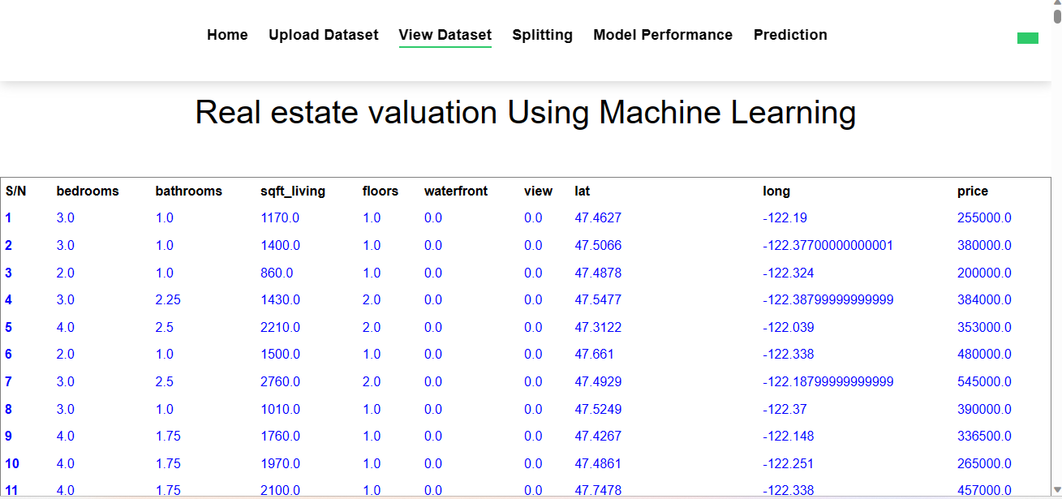

**FIGURE 5.1 DATASET**

11

**CHAPTER 6**

**SYSTEM DESIGN**

12

**SYSTEM DESIGN**

**ARCHITECTURE DIAGRAM:**

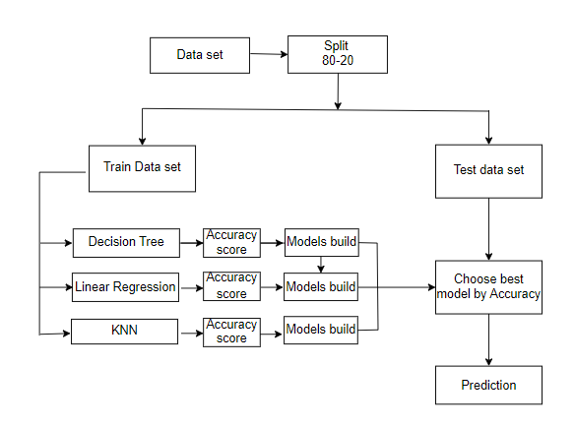

**Figure 6.1 ARCHITECTURE DIAGRAM**

13

**UML DIAGRAMS:**

UML (Unified Modeling Language) diagrams are visual depictions used in software engineering and system development to show the structure, behavior, and relationships of a system.

UML diagrams play a significant role in the software development lifecycle, assisting in analysis, design, implementation, and documentation, thereby boosting the clarity and comprehension of complex systems.

### Features:

* It is a language used for broad modelling.
* It differs from other programming languages like Python, C++, and others.
* It is related to analysis and design that is object-oriented.
* It is utilised to visualise the system's workflow.

14

**USE CASE DIAGRAM:**

A use case diagram is used to graphically displays the functional needs of a system or software application from the viewpoint of its users or actors. It gives a high-level picture of the system's activity and interactions with its external components.

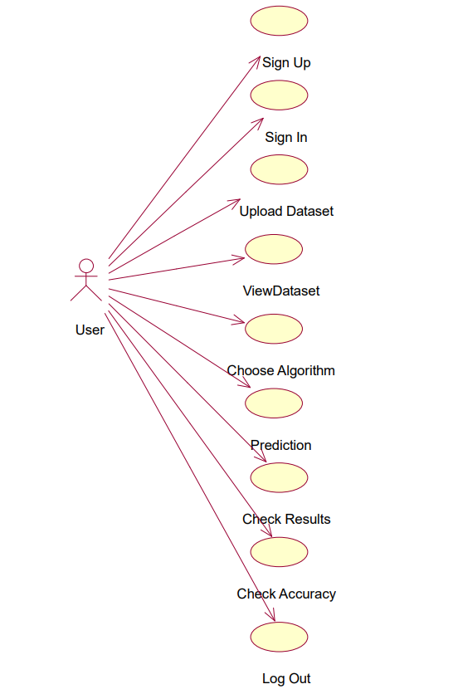

**Figure 6.2.1 Use Case Diagram**

15

## **ACTIVITY DIAGRAM:**

An activity diagram is used to visualize the flow of activities or processes inside a system or business process. It emphasises on the workflow or behavioral elements of a system, capturing the sequence of events, choices, and concurrency involved. Activity diagrams consist of nodes, edges, actions, and control components.

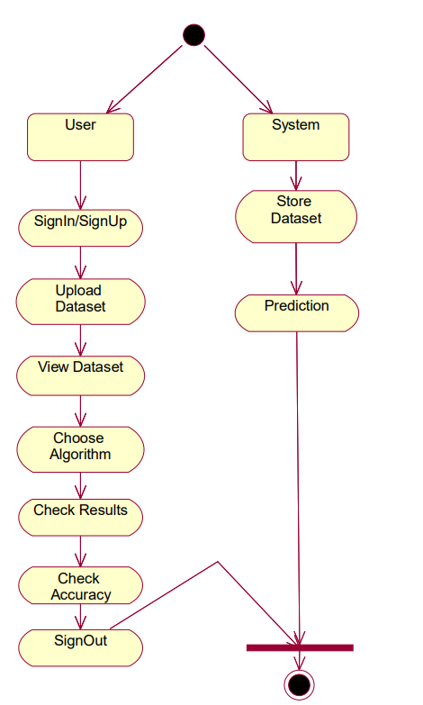

**Figure 6.2.2 Activity Diagram**

16

**SEQUENCE DIAGRAM:**

Sequence diagrams consist of lifelines, messages, and activation boxes. Lifelines indicate the items or components participating in the interaction, each portrayed as a vertical line. Messages are represented by arrows that link the lifelines, signifying the communication or connection between items.

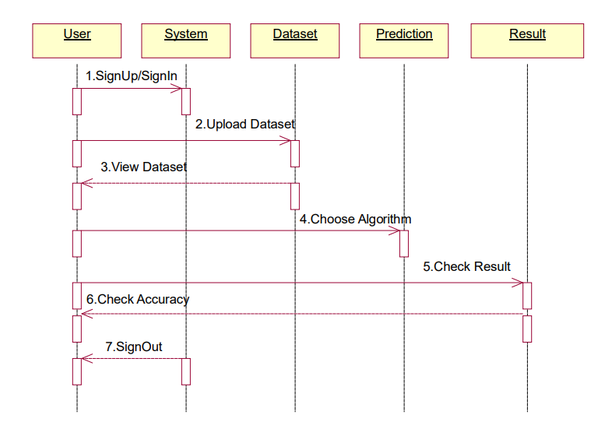

**Figure 6.2.3 Sequence Diagram**

17

**CHAPTER 7**

**IMPLEMENTATION**

18

**IMPLEMENTATION**

**SOFTWARE ENVIRONMENT :**

**PYTHON**

* Python is a high-level programming language noted for its simplicity and clarity.
* Python has a simple and legible syntax, which makes it easy to learn and comprehend. Its use of indentation as a technique to designate code chunks increases code uniformity and readability.
* Python supports numerous programming paradigms, including procedural, object-oriented, and functional programming.
* Google and Yahoo! both utilise Python a lot to make their Web crawlers and search engines work.

**FLASK**

* Flask offers a rapid debugger and an integrated development server.
* The documentation for Python Flask is vast.
* Additionally, it includes the integrated support essential for unit testing.
* Flask can also be installed in a virtual environment on Windows, Mac, and Linux.

INSTALLATION:

* pip install flask

**TECHNOLOGIES USED:**

**PANDAS:**

* Pandas is a robust open-source data manipulation and analysis package for Python. Pandas provides data structures and techniques that make it simpler to work with structured data and more.

**NUMPY:**

* + NumPy is a powerful Python library for numerical computations. It provides support for large, multi-dimensional arrays and matrices, along with a collection of mathematical functions to operate on these arrays efficiently.

**MATPLOTLIB:**

* Matplotlib is a popular data visualization package for Python. It includes a broad variety of functions and tools for making high-quality plots, charts, and figures

19

**ALGORITHMS**

**LINEAR REGRESSION**

**Linear Regression** is a supervised **machine learning** algorithm where the predicted output is continuous and has a constant slope. It's used to predict values within a continuous range, (e.g. sales, price) rather than trying to classify them into categories (e.g. cat, dog).

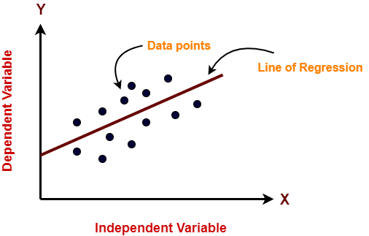

**K-NEAREST NEIGHBOR (KNN):**

* K-Nearest Neighbors (KNN) is a machine learning technique used for classification and regression tasks.
* It functions by locating the k avarage data points in the training set to a given input sample.
* The method predicts the class or value of the input based on the majority vote (for classification) or the average (for regression) of the neighbors.
* KNN is a non-parametric method, which means it does not make any assumptions about the underlying data distribution and may function effectively with various datasets.

**STEPS:**

* Choose the k-number of neighbors.
* Find the neighbors euclidian distances using k.
* Determine the k nearest neighbors in accordance with the calculation.
* Count the number of data points in each category among the k neighbors.
* The category with the greatest number of neighbors should receive the additional data points.
* Stop the operation.

20

**Decision Tree:**

The supervised learning approach known as a decision tree may be applied to classify and regression issues, although it is most typically utilised to deal with classification challenges. It is a tree-structured classifier, with internal nodes standing in for dataset characteristics, branches for decision-making procedures, and leaf nodes for conclusions.

**Steps to perform:**

* Identify the tree's root.
* Split the data based on select feature.
* Repeat the splitting process until a stopping condition is met.
* Set labels to every single leaf node.
* Prune the tree.
* Make predictions by traversing the tree from root to leaf node.
* Evaluate the model.

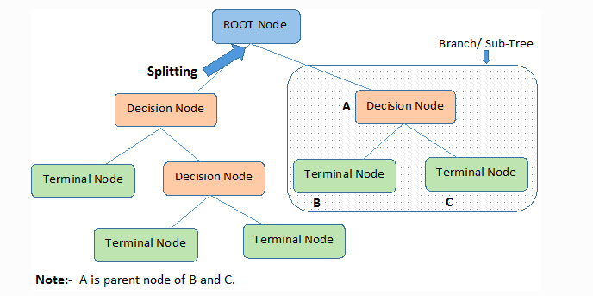

21

**CHAPTER 8**

**SOURCE CODE**

22

**SOURCE CODE:**

webapp.py:

import pandas as pd

from flask import Flask, render_template, request, url_for, flash, redirect, session

import os

from sklearn.model_selection import train_test_split

from prediction import X, y

import pymysql

import matplotlib.pyplot as plt

import numpy as np

filepath = os.getcwd()

webapp = Flask(__name__)

db = pymysql.connect(host='localhost', user='root', password='', db='house_price_prediction')

cursor = db.cursor()

webapp.config['UPLOAD_FOLDER'] = r"dataset"

@webapp.route("/")

def main():

return render_template("home.html")

@webapp.route("/reg", methods=['POST', 'GET'])

def reg():

if request.method == 'POST':

Name = request.form['name']

@webapp.route("/login", methods=['POST', 'GET'])

def login():

if request.method == 'POST':

Email = request.form["email"]

pwd = request.form["pwd"]

23

@webapp.route("/upload", methods=['POST', 'GET'])

def upload():

if request.method == 'POST':

myfile = request.files['file']

if ext.lower() == ".csv":

@webapp.route("/View")

def View():

myfile = os.listdir(webapp.config['UPLOAD_FOLDER'])

global full_data

@webapp.route('/split', methods=['POST', 'GET'])

def split():

if request.method == "POST":

test_size = float(request.form['size'])

global X_train, X_test, y_train, y_test

X_train, X_test, y_train, y_test = train_test_split(X, y, test_size=test_size,

@webapp.route("/model_performance", methods=['POST', 'GET'])

def model_performance():

if request.method == "POST":

model_no = int(request.form['algo'])

if model_no == 0:

print("You have not selected any model")

elif model_no == 1:

regressor_LR = LinearRegression()

regressor_LR.fit(X_train, y_train)

from sklearn.metrics import mean_squared_error, r2_score

@webapp.route('/prediction', methods=['POST', 'GET'])

def prediction():

if request.method == 'POST':

f1 = request.form['f1']

24

@webapp.route('/accuracy_graph', methods=['POST', 'GET'])

def accuracy_graph():

models = ['Linear Regression', 'Decision Tree Regressor', 'KNeighborsRegressor']

scores = []

for i in range(1, 4):

model_no = i

if model_no == 1:

regressor_LR = LinearRegression()

elif model_no == 2:

regressor_LR = DecisionTreeRegressor(random_state=0)

elif model_no == 3:

regressor_LR = KNeighborsRegressor()

regressor_LR.fit(X_train, y_train)

y_pred_lin = regressor_LR.predict(X_test)

from sklearn.metrics import mean_squared_error, r2_score

R2Score = r2_score(y_test, y_pred_lin)

scores.append(R2Score)

x = np.arange(len(models))

width = 0.35

colors = ['lightblue', 'lightgreen', 'lightcoral']

fig, ax = plt.subplots()

rects = ax.bar(x, scores, width, color=colors)

ax.set_ylabel('R2 Score')

ax.set_title('Accuracy Scores of Different Models')

ax.set_xticks(x)

ax.set_xticklabels(models)

24

**HTML CODE:**

<!DOCTYPE html>

<html lang="en">

<head>

<meta charset="utf-8">

<title>Real estate valuation</title>

<link href="static/lib/bootstrap/css/bootstrap.min.css" rel="stylesheet">

<link href="static/css/style.css" rel="stylesheet">

</head>

<body>

<nav class="navbar navbar-default navbar-trans navbar-expand-lg fixed-top">

<div class="navbar-collapse collapse justify-content-center" id="navbarDefault">

<ul class="navbar-nav">

<li class="nav-item">

<a class="nav-link active" href="/">Home</a>

</li>

<li class="nav-item">

<a class="nav-link" href="{{ url_for('reg') }}">Register</a>

</li>

<li class="nav-item">

<a class="nav-link" href="{{ url_for('login') }}">Login</a

</ul>

</div>

<button type="button" class="btn btn-b-n navbar-toggle-box-collapse d-none d-md-block" data-toggle="collapse"

data-target="#navbarTogglerDemo01" aria-expanded="false">

</button>

</nav>

</body>

</html>

25

**CSS CODE:**

*

{

margin:0;

padding:0;

font-family:'poppins',sans-serif;

box-sizing:border-box;

}

.container

{

width:100%;

height:100vh;

background-image:linear-gradient(rgba(0,0,50,0.8),rgba(0,0,50,0.8)),url(index.jpg);

background-position: center;

background-size:cover;

position: relative;

}

.container h1{

color:whitesmoke;

padding-top: px;

text-align: center;

font-family: Cambria, Cochin, Georgia, Times, 'Times New Roman', serif;

}

.content p{

color:whitesmoke;

font-size:25px;

padding-top: px;

text-align: center;

font-family:'poppins',sans-serif;

color:#FFFF00;

}

header, footer {

26

position: relative;

padding: 2em 3em;

display: flex;

align-items: center;

font-size: 1rem;

}

header {

position: -webkit-sticky;

position: sticky;

top: 0;

z-index: 2;

height: 10vh;

background-color: transparent;

}

header h3 {

position: relative;

margin: 5;

font-size: 2rem;

color: #FFFF;

}

27

**CHAPTER 9**

**OUTPUT SCREENS**

28

**HOME PAGE:**

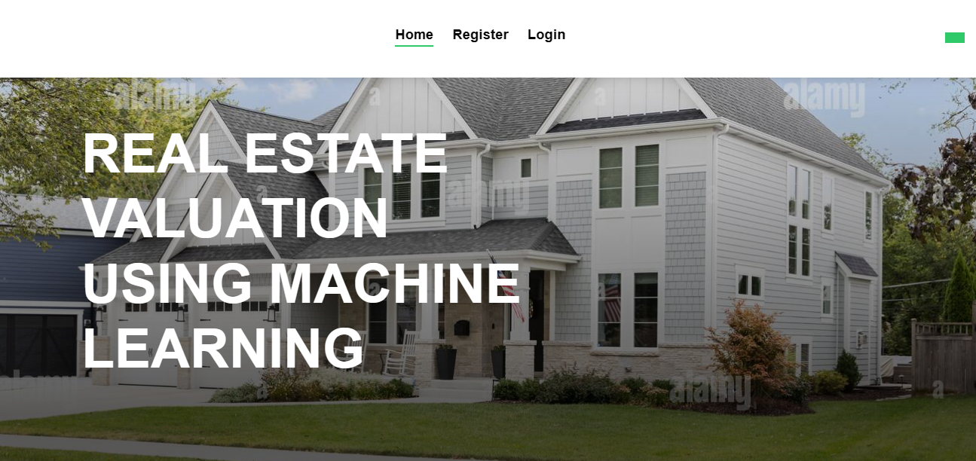

**FIGURE 9.1.1 HOME PAGE**

**REGISTRATION PAGE :**

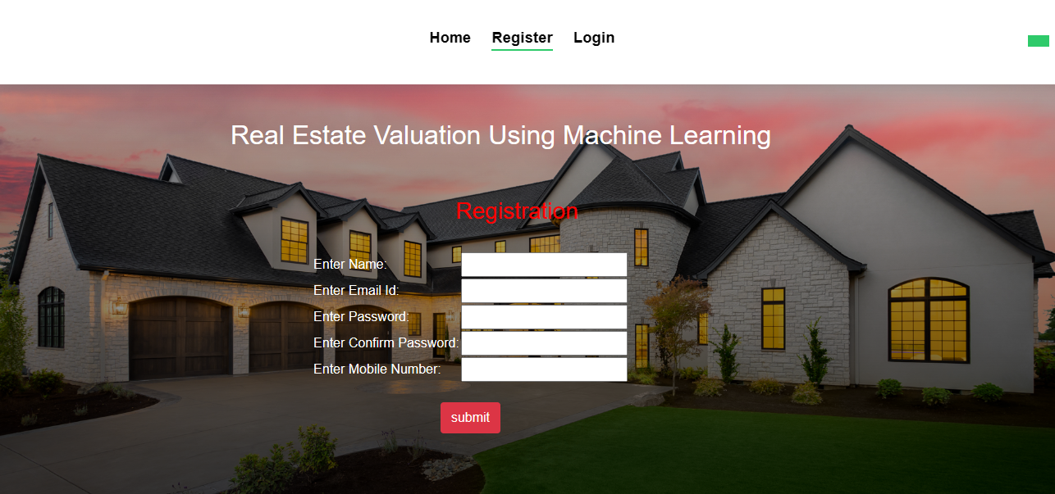

**FIGURE 9.1.2 REGESTRATION PAGE**

29

**LOGIN PAGE:**

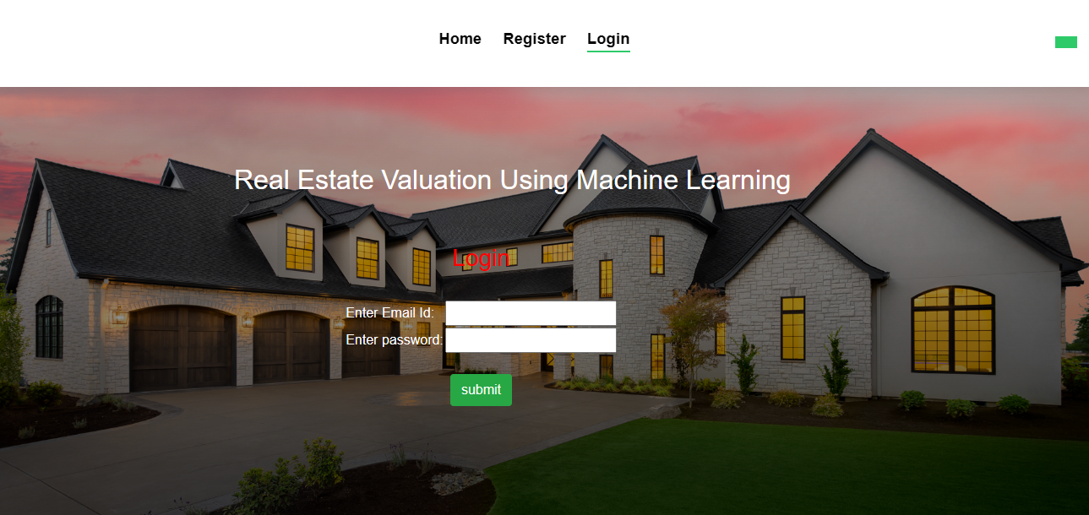

**FIGURE 9.1.3 LOGIN PAGE**

**UPLOAD DATASET PAGE:**

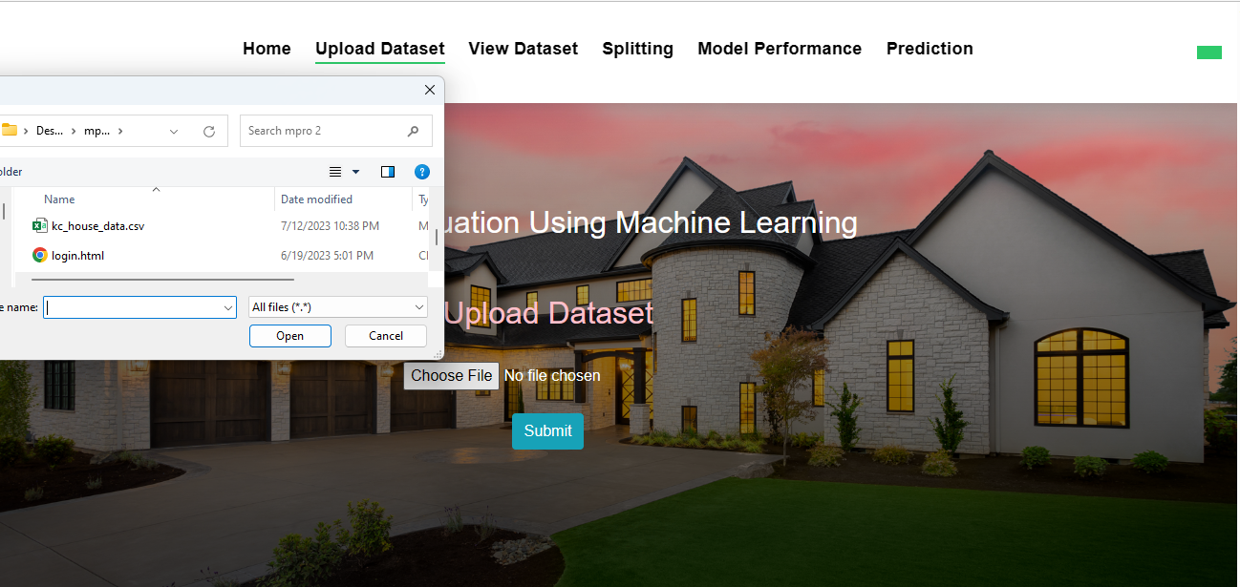

**FIGURE 9.1.4 UPLOAD DATASET PAGE**

30

**DATASET UPLOADED PAGE:**

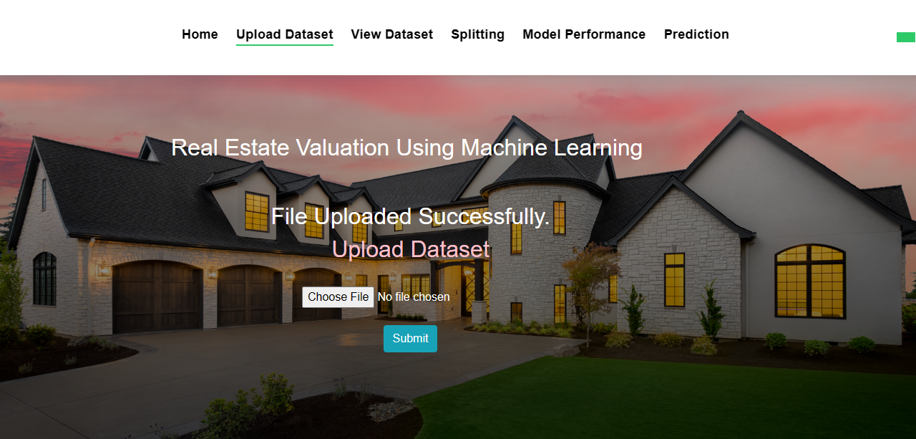

**FIGURE 9.1.5 DATASET UPLOADED PAGE**

**DATA VIEW PAGE:** 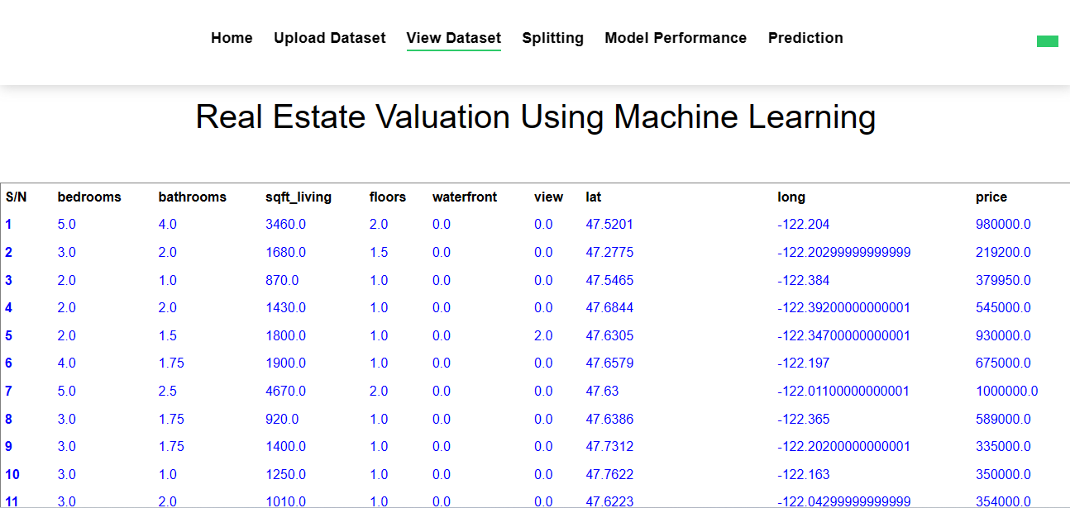

**FIGURE 9.1.6 DATA VIEW PAGE**

31

**SPLIT PAGE:** 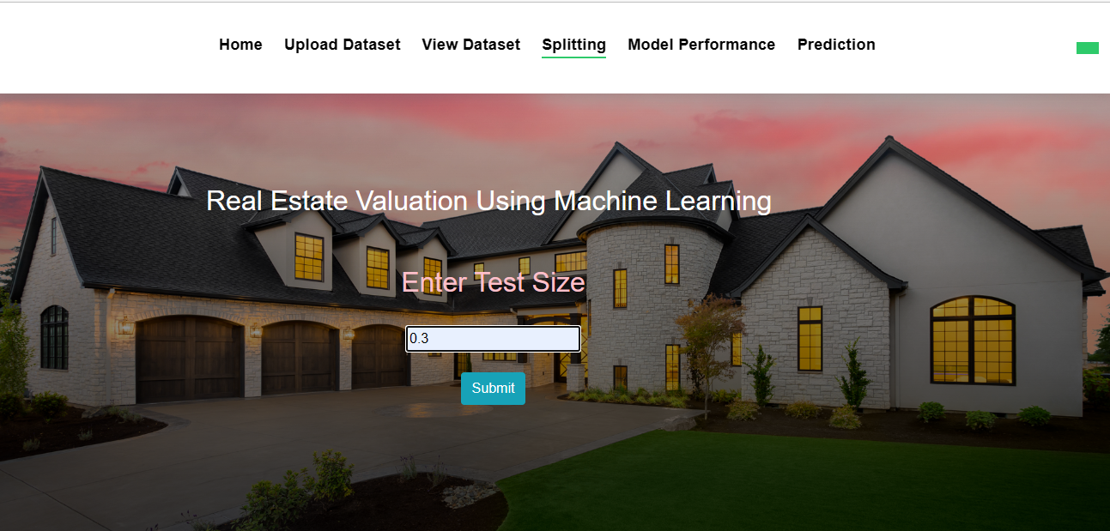

**FIGURE 9.1.7 DATA SPLIT PAGE**

**MODEL SELECTION PAGE:**

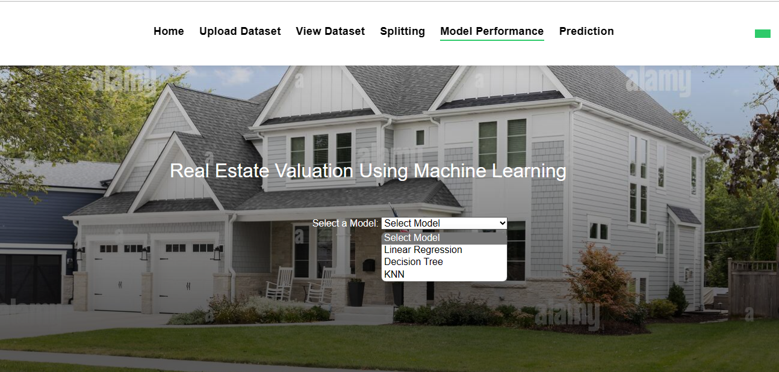

**FIGURE 9.1.8 MODEL SELECTION PAGE**

32

**ACCURACY PAGE:** 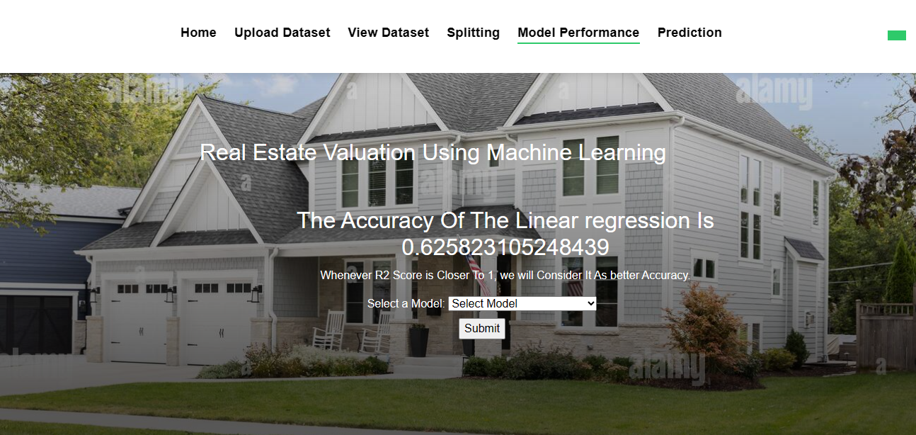

**FIGURE 9.1.9 LINEAR REGRESSION ACCURACY PAGE**

**ACCURACY PAGE :**

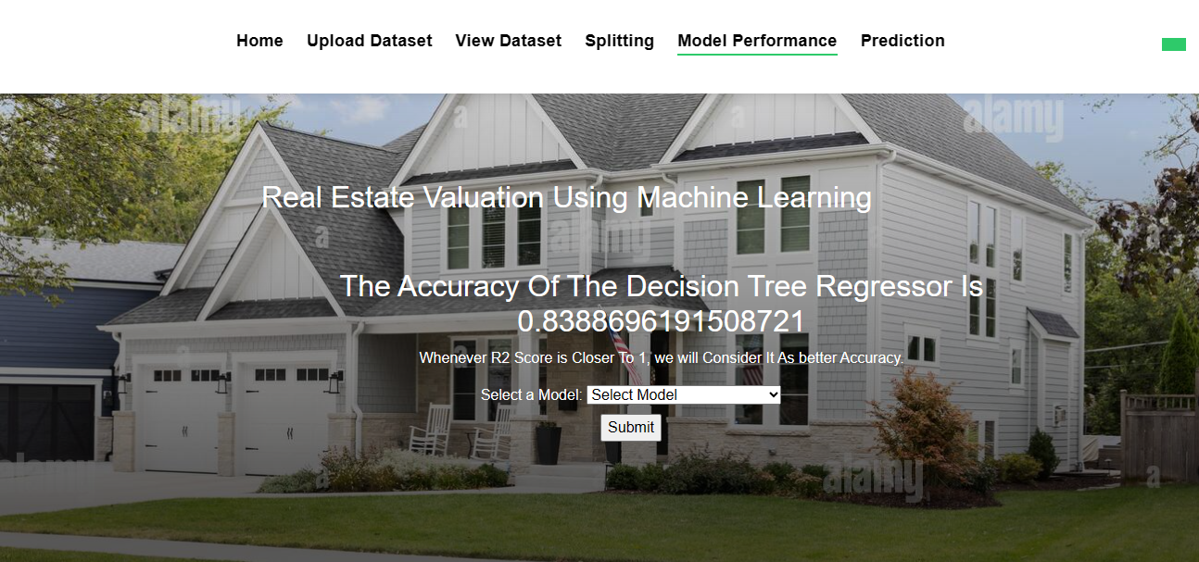

**FIGURE 9.2.0 DECISION TREE ACCURACYPAGE**

33

**ACCURACY PAGE :** 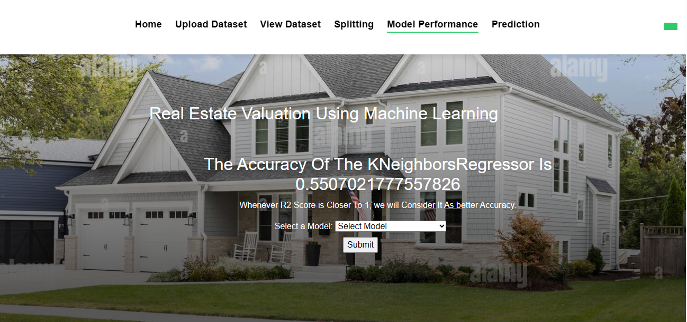

**FIGURE 9.2.1 KNN ACCURACY PAGE**

**INPUT PAGE :**

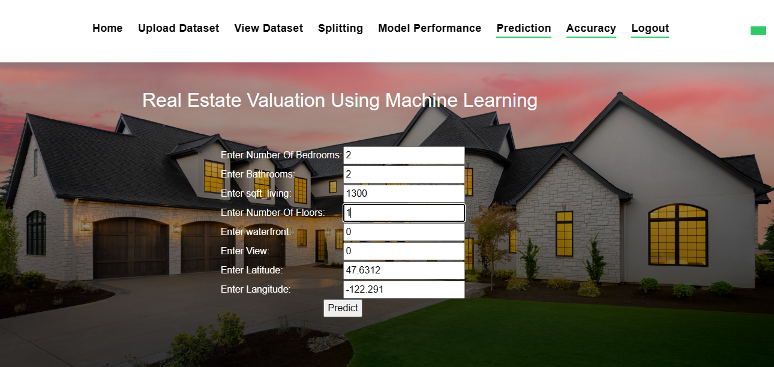

**FIGURE 9.2.2 INPUT PAGE**

34

**RESULT PAGE :**

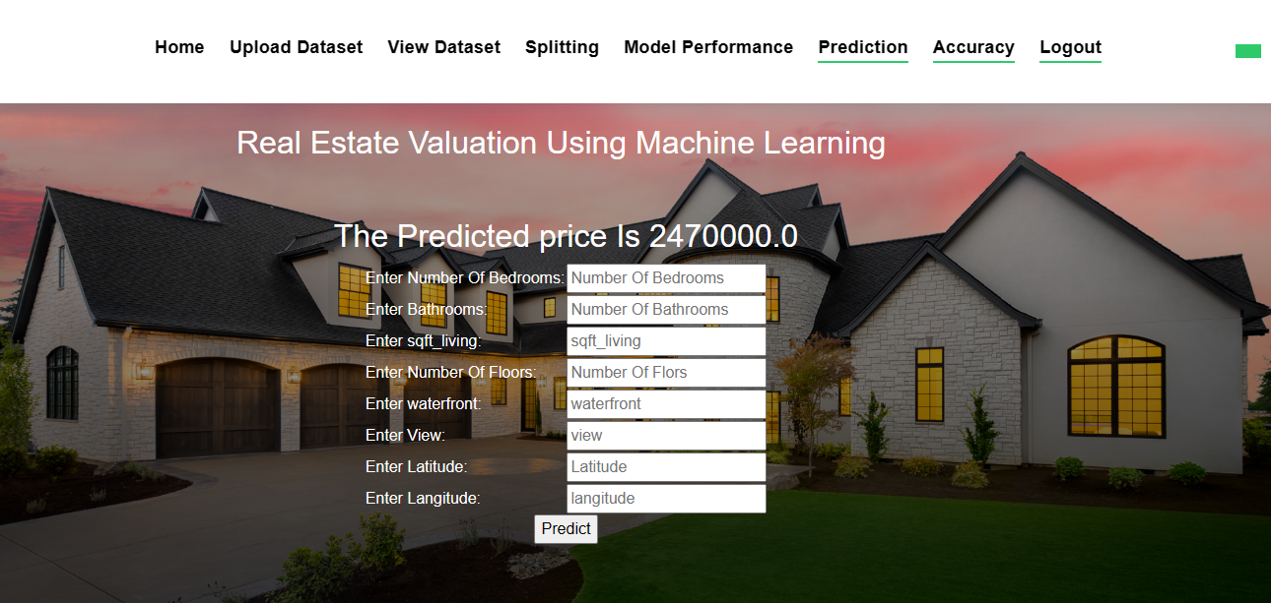

**FIGURE 9.2.3 PREDICTION PAGE**

**ACCURACY COMPARISION PAGE :**

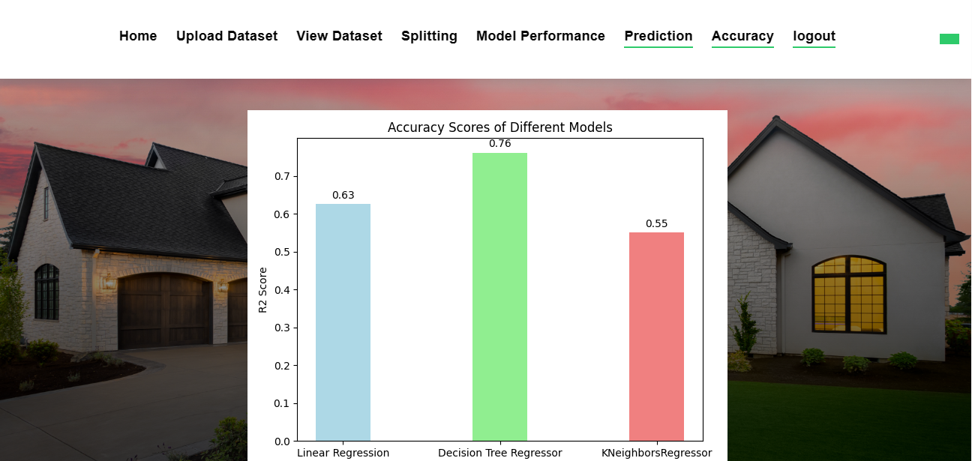

**FIGURE 9.2.4 GRAPH PAGE**

35

**CHAPTER 10**

**TESTING**

36

**SYSTEM TESTING:**

System testing ensures that the entire software system complies with the requirements. It evaluates a configuration to ensure that the consequences are understood and foreseeable. An illustration of a system test is the configuration-based system integration test. System testing is based on process flows and models, with a focus on links and interaction points that have previously been established.

**UNIT TESTING:**

Making test cases as part of unit testing entails confirming that the program's basic logic is solid and that genuine inputs result in valid outputs. The program's decision paths, and code flow should both be reviewed. Every piece of software that goes into a program is tested in this approach. It is finished after the completion of each component but before they are joined. This is an invasive test of the structure that depends on knowing how it was created. Unit tests execute rapid tests at the level of individual pieces and assess a single business method, software program, or system configuration. Unit tests guarantee that each individual route of a business process runs exactly as stated in the documentation and has explicit inputs.

**INTEGRATION TESTING:**

Integration tests are intended to check whether a program's component pieces perform as a single program. Testing is focused on events and is generally concerned with the functioning of screens or fields. Even though each component functioned brilliantly on its own, as evidenced by competent unit testing, integration tests showed that the components are coherent and consistent. Integration testing is aimed to uncover problems that appear when numerous components are integrated together.

**BLACK BOX TESTING:**

Black box testing includes analyzing software without having any knowledge of how it performs, how it is constructed, or what language it was written in. Black box tests need to be built from a clear source document, like a blueprint or standards document, much like the majority of other kinds of tests.

37

**CHAPTER 11**

**TEST CASES**

38

**TEST CASES:**

|  |  |  |  |  |  |
| --- | --- | --- | --- | --- | --- |
| S.NO | Test Cases | Input | Expected Output | Actual Output | Pass/Fail |
| 1 | If Login details are not filled. | A warning statement is to be displayed. | Users cannot get access to the next page. | User cannot get access to the next page. | Pass |
| 2 | If user enter the existing email while signup | Passing user email id. | The output should be already Email id exists | Already email id exists | Pass. |
| 3 | If user choose KNN algorithm | Passing type of house details. | To predict the price of the house. | It predicts house price. | Pass. |
| 4 | Dataset is uploaded or not. | Upload dataset. | Dataset is uploaded. | Dataset is uploaded. | Pass |

39

**CHAPTER 12**

**CONCLUSION**

40

**CONCLUSION:**

This system mainly concentrates on the comparison between different machine learning algorithms (Linear regression, Decision Tree, KNN) about Real estate valuation Analysis. From the system results, Decision Tree algorithm has high accuracy value when compared to all the other algorithms regarding real estate valuation. Here the [MSE] Mean Square Error and R2 score are used to calculate the accuracy value of the algorithm on the King County Dataset which was collected from Kaggle website. The can be extended by applying the above said algorithms to predict House resale value.

41

**CHAPTER 13**

**REFERENCES**

42

**REFERENCES**

[1]. Aminah Md Yusof and Syuhaida Ismail ,Multiple Regressions in Analysing House Price Variations. IBIMA Publishing Communications of the IBIMA Vol. 2012 (2012), Article ID 383101, 9 pages DOI: 10.5171/2012.383101.

[2]. Babyak, M. A. What you see may not be what you get: A brief, nontechnical introduction to over fitting regression-type models. Psychosomatic Medicine, 66(3), 411-421.

[3]. Atharva chogle, priyanka khaire,Akshata gaud, Jinal Jain .House Price Forecasting using Data Mining Techniques International Journal of Advanced Research in Computer and Communication Engineering ISO 3297:2007 Certified Vol. 6, Issue 12, December 2017

[4]. Darshan Sangani,Kelby Erickson, and Mohammad Al Hasan, Predicting Zillow Estimation Error Using SVR and Gradient Boosting, IEEE 14th International Conference on Mobile Ad Hoc and Sensor Systems (MASS), Page(s):530 - 534

[5]. Model,Azme Bin Khamis, Nur Khalidah Khalilah Binti Kamarudin ,Comparative Study On Estimate House Price Using Statistical And Neural Network, International journal of scientific and technology,research volume 3, ISSUE 12, December 2014,Page(s):126-131.

[6]. Adyan Nur Alfiyatin, Hilman Taufiq, Ruth Ema Febrita, Wayan Firdaus Mahmudy,Modeling House Price Prediction using Regression Analysis and Particle Swarm Optimization Case Study: Malang, East Java, Indonesia. (IJACSA) International Journal of Advanced Computer Science and Applications, Vol. 8, No. 10, 2017, Page(s):323-326

[7]. Aminah Md Yusof and Syuhaida Ismail ,Multiple Regressions in Analysing House Price Variations. IBIMA Publishing Communications of the IBIMA Vol. 2012 (2012), Article ID 383101, 9 pages DOI: 10.5171/2012.383101.

43